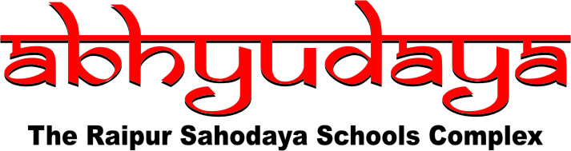
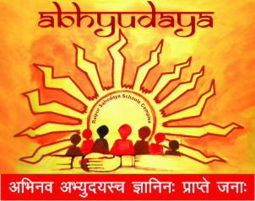
Abhyudaya Raipur Sahodaya Schools Complex,
Raipur (Chattisgarh), India

School Photo

Principal
Photo

SCHOOL PROFILE
Name of the Principal | Title | First Name |  |  | Last Name
Name of the School
Contact Details | Address
 | City |  |  | Pin code
 | State |  |  | Country
 | Phone
 | Email:
 | Web address:
Classes from
Type : Co-education/Boys/Girls
Groups offered in Classes XI :
Extra Curricular Activities :
Coaching class if any after School hours :
Facilities Available :

Is Boarding facility available :
Fee Structure (Optional) :
Probable admission dates :

